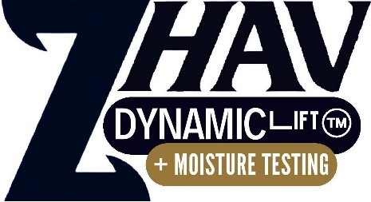

Prestige clinics with

zhav dynamic lift TM + Mositure testing

South Australia
Yaffa Zhav Anti-aging & Slimming Centre
55 The Parade West
KENT TOWN SA 5067
08 8277 6595
Serenity Advance Beauty Cosmetic Tattoo
186 Redbanks Rd
GAWLER BELT SA 5118
0405 716 969

Northern Territory
Alice’s Ultimate Beauty
Shop 10, Diarama Village
ALICE SPRINGS 0870
0400 463 590

New South Wales
Beauty Time
26 Hercules Street
DULWICH HILL 2203
0422 164 326
EDM Beauty
27A Kembla St,
WOLLONGONG NSW 2500
0401 736 948

